My homemade 3W Luxeon LED Dive Torch
Tested to 30 meters on many occasions. It has such a solid feel I am confident it can go much further.

This document describes the mechanical part of how I successfuly built a simple long lasting 3W LED dive torch using easy to obtain parts as with a total cost of well under €50.
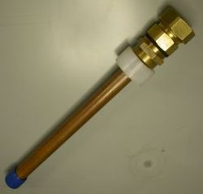
The main body of the torch takes four NiMH AA cells, but also works with other 1.2 or 1.5 Volt cells. An AVR controlled switch mode power supply limits the current into the LED to about 850 mA. The brown out circuit causes the light to blink when the NiMH cells are low.
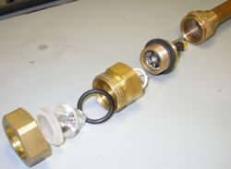
The parts used for the body of the torch from the bottom to the top are:
- 18mm copper end cap with soldered in spring for negative battery cell contact
- 18mm copper pipe to accomodate 4 AA size cells
- 18mm to 3/4" inner thread adaptor
- Teflon ring around adaptor, glued inside is the magnet for the reed switch
- 3/4" outside tread piece about 5 cm long with grove to hold rubber seal. Inside is a large piece of copper soldered into place to hold the 3W LED with some thermal grease and the circuit board.
- 3/4" inner tread to plastic pipe piece, inner tighning ring removed. Inside contains cut down lens holder between lens and LED
- Rubber seal
- Lens (in this case 10° version)
- Plexiglass disc
- Cap belonging to above mentioned 3/4" to plastic pipe piece.
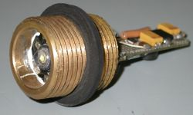
Most of the clever part is centered on the outer thread piece. The tread was removed and a small grove cut in the middle to prove a reliable place for the rubber seal.
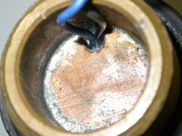
A very thick copper heat plate was soldered into the tread and a small hole allows the two wires for the LED to pass.
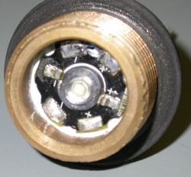
The 3W white Luxeon LED sits on one side of the plate and is held in place with some thermal conductive silicone. No fixing is required as the Lens holder provides some pressure on the LED circuit board.
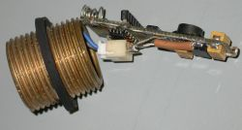
On the other side of the thread is the circuit board.
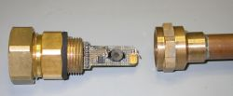
The tread is tightly srewed into the front part of the torch with the lens holder in place.
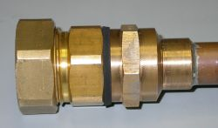
The back of the torch with the 4 batteries then forms the removable part at the back of the torch.
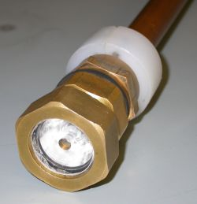
The Teflon ring is used to switch on the torch.
VOILA !

